Sprint Plan Document

# Heading

Sprint {3} Plan

Team number: 5, Section: 47406

Team member 1: Sara al-meshrai, ID: 435202339

Team member 2: Nora Alkhunifer, ID: 435201094

Team member 3: Asmaa Alrubia, ID: 435200178

Sprint start at: 16/11/2017

Sprint competition at: 21/11/2017

# Goal

In this sprint, we will complete the user stories with the highest priority, and try to follow them with the least priority user stories, finally we will test the app as a whole for all completed user stories.

# Task listing, organized by user story

User story 1 “As a user, I want to search by dish’s name, so that I save some time.”

Task 1 description: creating the search field. (2 hours)

Task 2 description: filtering the dish list based on the user input. (4 hours)

Total for user story 2: 3 days

User story 2 (As a user, I want the dishes list ordered by high rating, so that I know what is the best dishes)  
Task 1 description: adding a rate attribute to the dishes table in the database (time estimate for task 1 is half a day)  
Task 2 description: By default, the dish list code will be written to order all the dishes in the database in a descending order form the heights rating to the lowest rating (time estimate for task 2 is a half a day)  
Total for user story 2: 1 day

User story 3 (As a user of app, I want to rate any dish in app so that the system will add my rating on that dish)

~~Task 1: Start with CSS and bootstrap accomplishes a graphic for each of the three states: by defaults empty, full, and highlighted. (1 hour)~~

~~Task 2: Implement rating function to calculate dish rating base on specification (3 hours)~~

Task 3: Connect The rating function with database to save rating (2 hours)

Task 4: Update the average rating (2 hours)

Task 5: Update the number of raters (2 hours)

Task 6: Test unit [ rating function] (2 hours)

Total hours of user story 3: 10 hours

User story 4 “As a developer I want to link the implemented project to ionic dashboard and link all members with it in order to make it public for all clients”

Task 1: implement needed code for link (5 hours)

Task 2: test the connection (6 hours)

Task 3: upload it to ionic viewer (1 hour)

Total for user story 4: 2 days

User story 5 (As a user, I want to filter the displayed list by dish kinds, e.g: sweet, cake, so that I Minimize the dishes options.)  
Task 1 description: create a button corresponds to every dish type in the database. (1 hour)  
Task 2 description: link the button with a code that displays the dishes with that kind. (4 hours)

Task 3 description: label the clicked button. (1 hour)  
Total for user story 5: half a day

User story 6 (As a user, I want to filter the displayed list by event or meeting type e.g. party, visit a friend, so that I Minimize the dishes options)  
Task 1 description: create a button corresponds to every event or meeting type in the database. (2 hours)  
Task 2 description: link the button with a code that displays the dishes having that meeting type. (5 hours)  
Task 3 description: write the code that allows more than one button to be clicked. (4 hours)

Task 4 description: make the clicked buttons labeled. (1 hour)  
Total for user story 6: 2 days

User story 7 (As a user of the app, I want to view notification on app icon in order to know if someone add tip to my dish).

Task 1 description: update database. (2 hours)  
Task 2 description: update app design. (4 hours)  
Task 3 description: write the code that sends or take in the event to be notified. (6 hours)

Task 4 description: write the code that notifies a user. (6 hour)  
Total for user story 7: 3 days

User story 8 “As a user of app, I want to select type of occasion for any dish in app so that the system displays the most three of user chooses.”

Task 1: discover all local occasion names and download the match icons. (4 hours)

Task 2: add occasion names and icons in the system. (2 hours)

Task 3: add cancel options. (2 hour)

Task 4: create scroll chick-list form for all occasions saved. (3 hours)

Task 5: add selected occasions to dish database. (2 hours)

Task 6: Code Review (2 hours)

Task 7: testing. (3 hours)

Total for user story 8: 18 hours

# Initial task assignment

Asmaa Alrubia: user story 3,8 all tasks

Nora Alkhunifer: user story 4,7 all tasks

Sara al-meshrai: user story 1,2,5,6 all tasks

**Initial burndown chart**

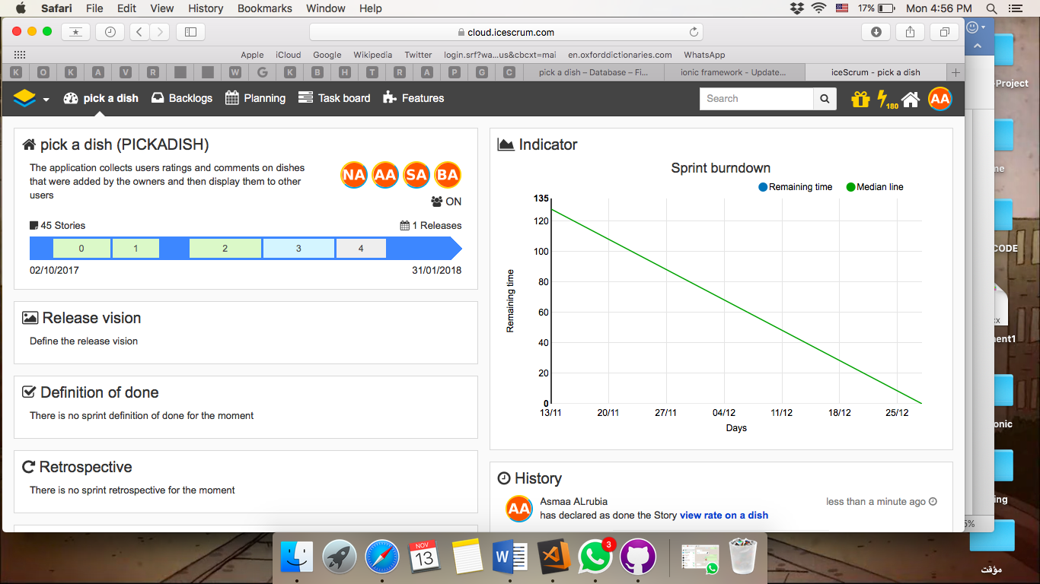

**Initial scrum board**

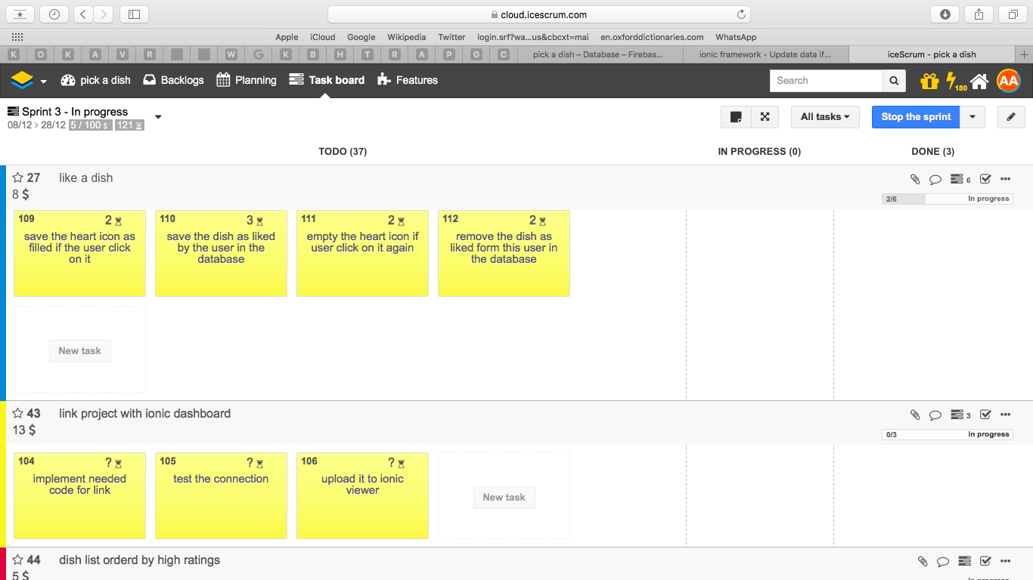

# Scrum times

Every Tue 1-3PM.

Every Thu 8-10AM.

Every Friday 8-10AM.